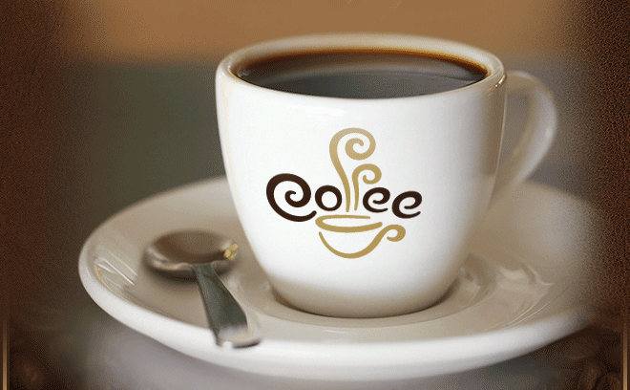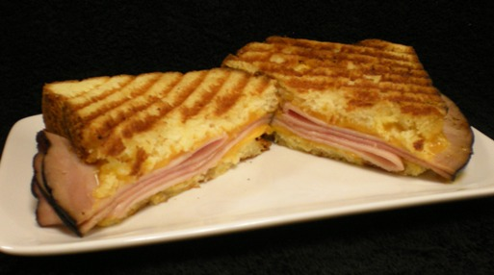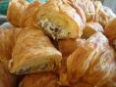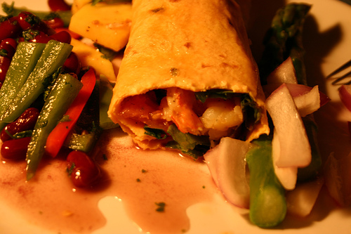

**DESSERT PRICE - $4.00**

**BREAD PUDDING VARIETIES**

**(Subject To Availability)**

**PECAN**

**COCONUT/PECAN**

**CARAMEL/PECAN**

**\*CHECK THE CAFE FOR CURRENT DESSERT OFFERS.**

**SIGNATURE DESSERTS**

FIRST BAPTIST CHURCH ORANGE

7637 MLK DRIVE

ORANGE, TEXAS 77632

**FIRST CUP CAFE**

**MENU**

**MEAL DEALS INCLUDE:**

**SANDWICH, CHIPS, & COKE PRODUCT**

CHICKEN SALAD ON CROISSANT $8.99

FLAMEADA FAJITA SANDWICH $8.99

CHICKEN QUESEDILLA $8.99

SOUR DOUGH GRILLED CHEESE $7.99

HAM AND SWISS PANINI $7.99

PIMENTO CHEESE ON CROISSANT $7.99

KIDS GRILLED CHEESE MEAL $3.50

(INCLUDES FRUIT SNACK, JUICE, CHIPS)

SALADS

"BIG SALAD" (Lettuce, Tomato, Cucumber, $8.99

Ham, Swiss & Crunchies)

GREEK SALAD-(Romaine, Black Olives, $9.99

Tomato, Cucumbers, Feta Cheese, Capers,

Greek Balsamic Dressing) ADD CHICKEN ($1.00)

GRILLED CHICKEN GREEN SALAD $10.99

(Cucumbers, Tomatoes, Cranberries, Almonds, Chicken )

GRILLED CHEESE (**Adults)** $5.99 (**Kids**) $3.00

**HOURS**

**M-TH 9-2**

**SANDWICHES**

DRINKS

HOPE COFFEE (DAILY BLEND)$1.79-$1.95

**Also available:**

SPECIALTY COFFEES

SMOOTHIES

ITALIAN CREAM SODAS

ITALIAN SODAS

FRAPPES

COKE PRODUCTS

BOTTLED WATER

**Call-in orders are welcome**.

Call Diane - 409-659-0875

OR Trina -201-1475

**TO BOOK YOUR GROUP EVENT !**

CALL **TRINA** AT 409-**201-1475**

FOR MORE INFORMATION.



